

# WHY THE PHILIPPINES IS THE BEST CHOICE FOR OUTSOURCING

From its skilled workers, cultural adaptation and most especially, the costs - the Philippines has finally taken flight primarily through its business process outsourcing (BPO) which have sprung up across the country.

Centered around Manila, Cebu, and Davao City, the abundance of talent at a lower cost made the Philippines a much more viable option in recent years. From the get go, it is a race with India as its main threat, the Philippines quietly and quickly emerged as a superpower in the outsourcing industry.

India, which is used to the notion of the country being the undisputed leader in offshore services, has just learnt with some surprise that in the volume (voice or call centre) segment of the BPO space, it has been outpaced by the Philippines.

Several factors, like a well-educated workforce, good language competencies and work ethic, have made the Philippines an attractive BPO destination.

“Hard working is good but if you don't have strong communication, how clearly can an Indian understand the real problem and how well can they express the solution so that the customer understands? Filipinos are better English speakers many Americans can better relate to and their skills and talents are only getting better. Indians still have difficulties with slurred pronunciations and English comprehension,” cites one business commentator in the reputed The Times of India

The Philippines has established itself as one of the top destinations globally for Offshoring and Outsourcing (O&O) operations. From less than USD 100 million in total revenues 2001, the Philippines increased O&O revenues to USD 3.3 billion 2006, effectively doubly every year. This high rate of growth has persisted even as the industry has grown beyond its initially low base. Between 2004 and 2006, the industry grew 49 percent per year. As a result of this growth, the Philippines is now the Southeast Asia market leader. One of the top countries providing O&O services globally.

Foremost among the intrinsic strengths that have drawn O&O to the Philippines is a sizeable and skilled labor force. The nation produces nearly 500,000 college graduates per year across a range of discipline that align well with the O&O industry. Nearly 150,000 graduate from business related programs, while another 100,000 are from engineering or information teachnology (IT) programs. The Philippines is also one of the few countries that can boast a large number of English speaking college graduates each year.

C:\STOCKLAYOUTS\CURRENT PROJECTS\FN99804-PL\FN99804-IMG02.emf

C:\STOCKLAYOUTS\CURRENT PROJECTS\FN99804-PL\FN99804-IMG02.emf

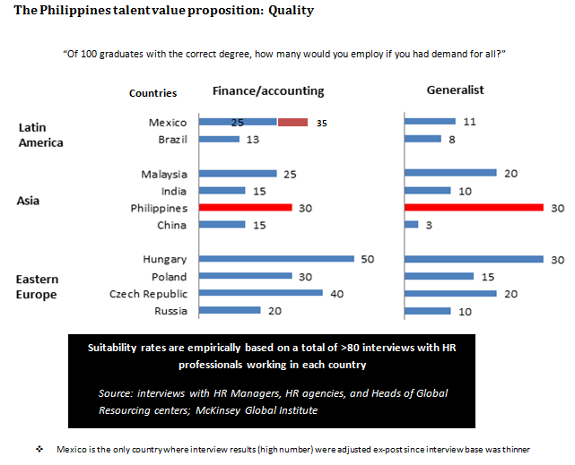

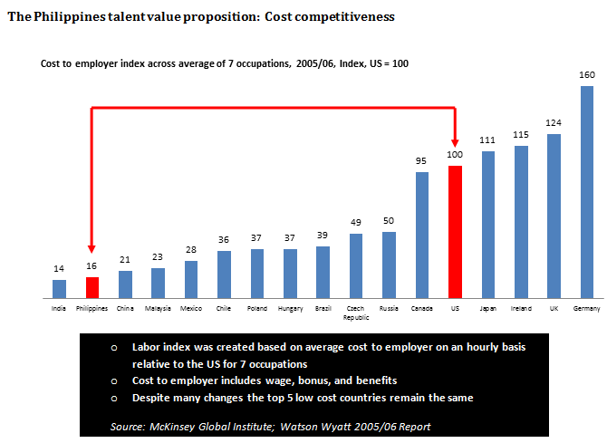

In a recent article by The Times of India, The Philippines surge in the industry was cited wherein Wipro Ltd, based in Bangalore, India, set up in the Philippine city of Cebu in 2007 and now has 2,000 workers in the country. By 2014, it expects to have 8,000. 24/7 Customer, which started operations in India in 2000, opened a Philippines office in 2005. It now has 4,000 employees in the country, compared with 3,000 in India. Tata Consultancy Services Ltd, India’s largest software services firm, said on December 2 it would open a business processing outsourcing centre in the Philippines. “It’s very sad that India could not keep up with its neighbours,” 24/7 co-founder Shanmugam Nagarajan said.

“Ten years down the line, the Philippines may be a hotter destination,” said Sanjeev Bhatia, who oversees international operations for Wipro’s BPO. “But in IT and software, India really doesn’t have any competition.”

The Philippines also produces only about 10 per cent as many engineers as India, according to graduation data from both countries. India’s ready supply of engineers has helped its outsourcing firms go from answering phone calls to account management, technical support and consulting jobs that include helping banks manage financial derivatives and improving retailers’ supply chains. Only If the Philippine government can fully develop the information-technology and business-process outsourcing (IT-BPO) sector services industry, it has the potential to earn export revenues of $30 billion to $55 billion by 2020.

This is according to a study made by World Bank consultant Raja Mitra, who estimates that medium-term export revenues from the sector could reach far more than the $9 billion it controlled in 2010. Mitra made three assumptions that resulted in a low-end medium-term export revenue estimate of around $30 billion, the medium-end estimate at $45 billion and the high-end estimate at $55 billion. “While not a panacea...expanding the scale and scope of exports of IT-BPO services as well as domestic industry development and use of ICT [information and communication technology] will offer new avenues that can help the economy to be more productive and accelerate efforts to achieve inclusive growth within the country and to interface and catch up with the rest of the world,” Mitra said. With revenues of this size, Mitra expects the IT-BPO services industry to contribute as much as 11 percent of the country’s gross domestic product (GDP) by 2020. In 2010 the industry contributed around 5 percent of GDP. Mitra also projects that Filipinos employed directly and indirectly by the industry will reach 6.8 million by 2020. Those who will be directly employed by the industry could increase to 1.8 million by 2020 from 500,000 in 2010, while those who are indirectly employed could rise to 5 million by 2020 from 1.75 million in 2010.

However, these are merely projections and, in truth, Mitra said, the Philippines’ full potential in the industry has not been met. For one, the country lags behind in providing IT-related services and the use of high technology in all its IT-BPO services. Mitra said these two factors would significantly help in growing the industry and allowing the Philippines to also shift to high-value back-office services, which are necessary to earn in more revenues. “[It is] important to simultaneously develop the IT, telecom, education and other knowledge economy sectors and to enhance the potential synergies between BPO and other ICT sectors both in terms of external and domestic markets. Such a development offers significant promise it can contribute toward achieving sustainable and inclusive economic growth,” Mitra said. Mitra said the Philippines already has a larger BPO industry than India and has already overtaken it in call-center operations. Metro Manila now has more people employed in the BPO export industry than any other city in the world. Data collected by Mitra showed that the sector’s export revenues-ratio-to-GDP was less than 1 percent in the early 2000s and steadily grew to 4.8 percent in 2009. Its share of total exports, on the other hand, increased to 16 percent in 2008 from less than a percent in 2000.

Mitra also said the industry has already come a long way in boosting employment in the country. For one, direct employment in the sector as a share of the total labor force employment has risen to more than 1 percent from less than 0.1 percent in the early 2000s.